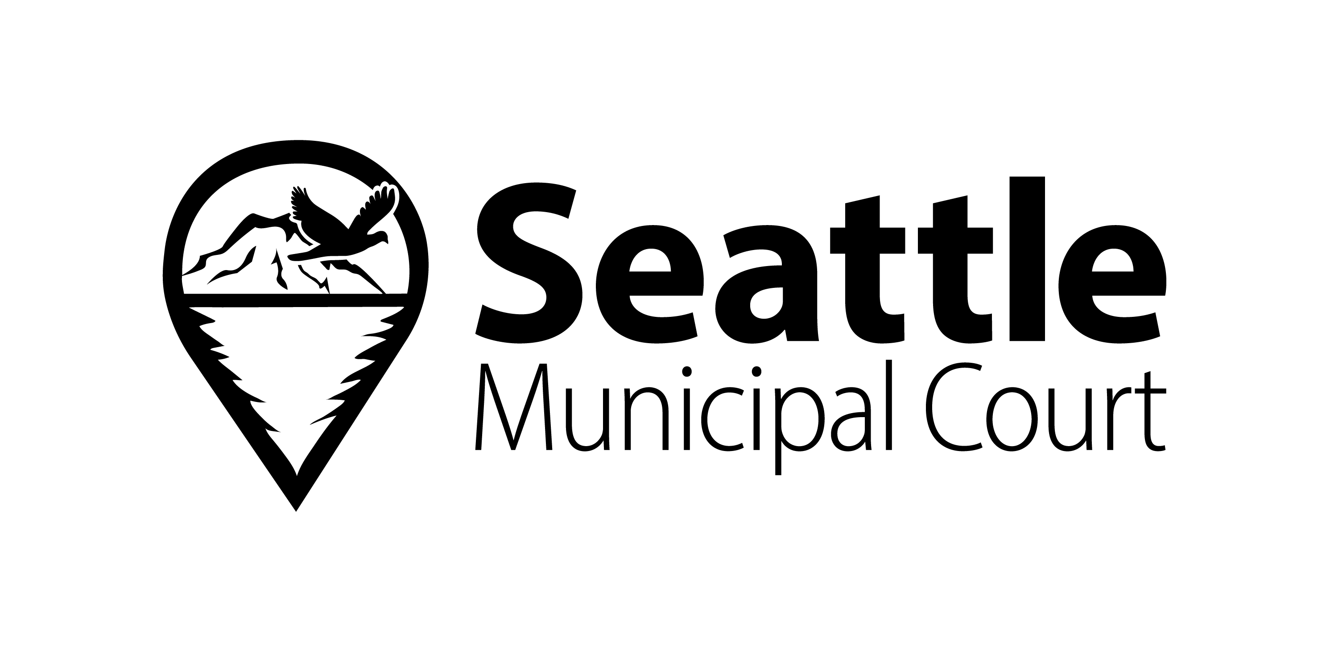
Language Access Plan (LAP)
Effective Date: August 1, 2025

1. Purpose
This Language Access Plan (LAP) describes the policies and procedures used by Seattle Municipal Court to provide timely and effective language access services. These services ensure meaningful access to court programs and services for individuals with limited English proficiency (LEP) and individuals who are deaf, hard of hearing, or deaf-blind (D/HH/DB).

2. Court Policy Regarding Language Access Services
Seattle Municipal Court complies with all applicable federal and state laws, including Title VI of the Civil Rights Act of 1964, the Americans with Disabilities Act (ADA), RCW 2.42 and RCW 2.43, and the Omnibus Crime Control and Safe Streets Act of 1968.

3. Data Collection and Needs Assessment
Seattle Municipal Court conducts an annual assessment of language access needs using demographic, court, and community data. The data is reviewed to ensure appropriate allocation of language access resources.

3.1 Identified Current Needs
- Spanish
- Vietnamese
- Somali
- Amharic
- Mandarin
- Korean
- Tigrinya
- Punjabi
- Cantonese
- Arabic
- Samoan
- Swahili
- Khmer (Cambodian)

3.2 Identified Future Needs
Future language access needs include expanded interpreter availability, additional interpreter training, and improved access to qualified ASL and Korean interpreters.

4. Language Assistance Identification and Resources

4.1 Designated Language Access Office
The Office of Interpreter Services coordinates language access services, including interpreter scheduling, tracking requests, and assisting court users and staff.

5. Language Access Services

5.1 Services Inside the Courtroom
The Court appoints credentialed interpreters whenever possible and documents good cause when a non-credentialed interpreter is used.

5.2 Services Outside the Courtroom
Language access services are provided for court-managed programs including probation, records, payment services, and interviews.

5.3 Translated Forms and Documents
Translated court forms and informational materials are provided in frequently used languages. Automated translation tools are not used for official court communications.

6. Training
Seattle Municipal Court provides ongoing training for judges, staff, and administrators on interpreter use, language access requirements, and best practices.

7. Complaint Process for Non-Compliance
Individuals may file complaints regarding language access services through the Court’s complaint process or with the Washington State Interpreter Commission.

8. Public Notification and Evaluation of the LAP
The LAP is posted on the Court’s website and evaluated annually. Updates are communicated to staff and the public.

9. Contact Information
Seattle Municipal Court
Luisa Gracia, Interpreter Services Strategic Advisor
Email: mailto:luisa.gracia@seattle.gov
Phone: 206-733-9075

